**Skills needed at secondary schools.**

**Students will need to develop many of the following skills in order to cope with the demands of secondary school as successfully and independently as possible.**

Key:

Red – Not developed Yellow – Developing Green - Achieved

**Organisation skills**: - They will need to:

|  |  |  |  |
| --- | --- | --- | --- |
| **Skill to be developed** |  |  |  |
| Understand and use timetables independently |  |  |  |
| Use homework diaries / planners effectively (e.g. record homework / important dates / deadlines ; make a note of changes to timetable etc) |  |  |  |
| Cope with multiple teachers |  |  |  |
| Move from one classroom / area to another independently (using a map/plan initially) |  |  |  |
| Understand directions eg “right” and “left” |  |  |  |
| Pack own school bag, remembering PE kit, swimming kit, cooking ingredients etc |  |  |  |
| Make lunch arrangements (e.g. lunch card/money/packed lunch) |  |  |  |
| Have pens, pencils and correct books and equipment or each lesson. |  |  |  |
| Take responsibility for own possessions e.g. pencil case in bag, coat/equipment in locker |  |  |  |
| Get uniform ready for next day |  |  |  |
| Take out and return library books independently |  |  |  |
| Arrange travel to and from school (including bus pass, money, keys, bike lock) |  |  |  |
| Organise personal time to include homework and extra-curricular activities. (Including revision time) |  |  |  |
| Organise a space to work at home |  |  |  |
| Hand in homework on time |  |  |  |
| Plan ahead for future events e.g. trips, buying cooking ingredients. |  |  |  |
| Understand the importance and significance of good time keeping and planning for the future |  |  |  |

**Curriculum access skills: -** They will need to:

|  |  |  |  |
| --- | --- | --- | --- |
| **Skill to be developed** |  |  |  |
| Focus attention independently on task for a specified amount of time |  |  |  |
| Develop skills in note-taking, using Mind Maps, summarising |  |  |  |
| Develop revision strategies e.g. highlighting, colour coding, flash cards, reading Mind Maps |  |  |  |
| Develop an awareness of which strategies work best for them |  |  |  |
| Be aware of and contribute to personal targets and attainment levels |  |  |  |



**Vocabulary associated with secondary school**: - They will need to:

|  |  |  |  |
| --- | --- | --- | --- |
| **Skill to be developed** |  |  |  |
| Understand subject names e.g. “Maths” (previously numeracy), Humanities, DT, ICT |  |  |  |
| Understand terminology used in secondary school e.g. ‘session’ / ‘period’. ‘tutor’ ‘break’ |  |  |  |
| Understand names of buildings and departments e.g. Science lab, art department, student services, learning support. |  |  |  |
| Use correct term of address e.g. “Sir”, “Miss”, “Mr…” |  |  |  |
| Understand abbreviations e.g. “SCI” for Science and staff initials on timetables |  |  |  |

**Problem solving skills: -** They will need to**:**

|  |  |  |  |
| --- | --- | --- | --- |
| **Skill to be developed** |  |  |  |
| Know what to do / where to go there are changes or if something is different |  |  |  |
| Know what to do if they forget something |  |  |  |
| Make one-off arrangements e.g. after school clubs, travel etc |  |  |  |
| Ask for help and explain what they need help with |  |  |  |
| Develop trust in a number of support staff, ie not rely on only one person |  |  |  |
| Know who can help in a specific circumstance e.g. subject teacher, pastoral team, SEN team |  |  |  |
| Know their own phone number, address and who to contact in an emergency |  |  |  |
| Focus on relevant visual clues to aid understanding of content |  |  |  |

**Higher level language skills: -** They will need to**:**

|  |  |  |  |
| --- | --- | --- | --- |
| **Skill to be developed** |  |  |  |
| Understand and use words with two meanings e.g. ‘table’ or “blew” and “blue” |  |  |  |
| Understand and use idioms |  |  |  |
| Understand questions at higher levels eg ‘why’, ‘how do you know?’ (Blank levels 3-4) |  |  |  |
| Develop inference skills ie reading between the lines |  |  |  |
| Develop awareness of sarcasm, tone of voice and humour |  |  |  |

**Time skills: -** They will need to**:**

|  |  |  |  |
| --- | --- | --- | --- |
| **Skill to be developed** |  |  |  |
| Be able to tell the time - digital and analogue |  |  |  |
| Know how long lessons last, and when each lesson starts / finishes |  |  |  |
| Understand sequencing and words such as ‘first, next, last’ |  |  |  |
| Know what time the school day starts / finishes, and the times for break and lunch time |  |  |  |
| Understand “before” and “after” |  |  |  |
| Know days of the week |  |  |  |
| Know months of the year |  |  |  |
| Know seasons and term names |  |  |  |
| Understand the academic year e.g. how long terms and holidays last |  |  |  |
| Know the dates of important festivals and celebrations. |  |  |  |
| Plan ahead for the future and understand the implications for now e.g. working hard to achieve results for choice of jobs in the future. |  |  |  |
| Realise the possible consequences of behaviour. |  |  |  |

**Social skills: -** They will need to**:**

|  |  |  |  |
| --- | --- | --- | --- |
| **Skill to be developed** |  |  |  |
| Make and maintain friends. |  |  |  |
| Talk to peers appropriately. |  |  |  |
| Have good conversational skills. |  |  |  |
| Keep on topic. |  |  |  |
| Look towards the person who is speaking |  |  |  |
| Use language and vocabulary that is appropriate for the situation and the other people e.g. talk differently to peers vs parents vs teachers. |  |  |  |
| Deal with different teaching styles and modes of communication |  |  |  |
| Understand and read facial expressions and other non-verbal communication e.g. body language |  |  |  |
| Take responsibility for own behaviour. |  |  |  |
| Understand social norms and expectations as they mature |  |  |  |
| Use appropriate register i.e. appropriate language to match the age/ status /role of the listener |  |  |  |
| Realising the consequences and impact of what you say |  |  |  |

**Use of language: -** They will need to**:**

|  |  |  |  |
| --- | --- | --- | --- |
| **Skill to be developed** |  |  |  |
| Contribute to speaking tasks and class discussions |  |  |  |
| Work as part of a team in a group to achieve a common goal |  |  |  |
| Share ideas in a small group |  |  |  |
| Sequence ideas in a logical order for recounting events |  |  |  |
| Use meaningful spoken sentences ( and record these in writing / notes) |  |  |  |



**Useful resources**:

Looking and thinking Black Sheep Press – secondary

Speech Bubbles Black Sheep Press – school

100% Language Black Sheep Press – feelings and emotions

Speechmark - Time Matters (2015)

Speechmark Colorcards (Time, Sequencing)

**Language Development in the secondary years**

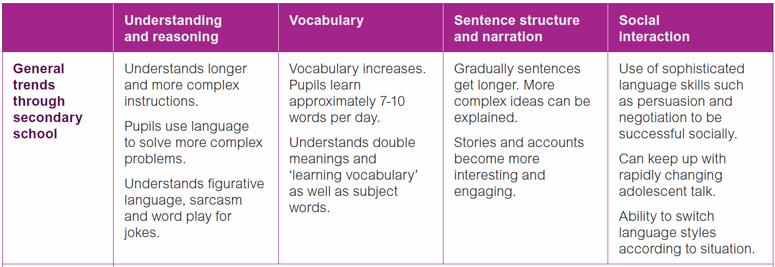From Speech, Language and Communication in secondary aged pupils ([www.ican.org.uk](http://www.ican.org.uk) )