

January 2022

**38%**

of parents said that their child either does not attend school at all or attends less than 25% of the time

**58%**

of parents indicated that their child finds/found attending school ‘extremely difficult’

**71%**

explained that their child’s difficulty has lasted more than a year

**24%**

stated that their child has had a school exclusion

**52%**

of parents revealed that their child had been on a part-time timetable due to EBSA

In the Autumn 2021 school term, parents across Milton Keynes gave their views on EBSA. They completed a questionnaire, developed with PACA and SENDIAS, as part of the EBSA project working group.

* Questionnaire responses: **79**
* Additional information shared via a call back: **5**

**Feedback Collection:**

Emotionally-Based School Avoidance: Parent Questionnaire Responses

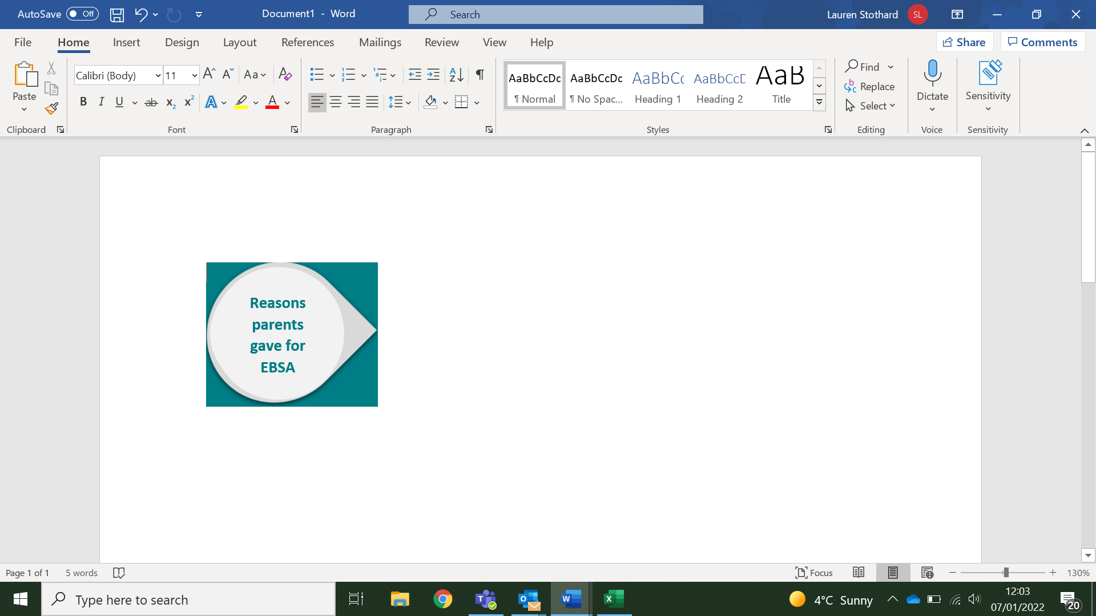

“No real place to go and feel safe”

“Sensory challenges of school, with crowds, chaos, noise”

**Other suggestions for improved support/information:** (examples)

* Relationships and consistency with teaching staff
* Better communication
* Enhanced awareness, understanding and training
* Flexible, person-centred education
* One-to-one teaching

**Other services/resources/support parents found useful:** (examples)

* Milton Keynes Local Offer
* PACA MK
* SENDIAS
* CAMHS
* Ride High

School attendance was negatively impacted by COVID-19 for many, for example: “(it) hugely accelerated her displeasure attending school” and “changes in routine/drop offs procedures frequently causes difficulties”

However, other children benefitted by lockdown/school closures: “Mine thrived at home in lockdown” and “Covid closures have been an asset to my son who returned to his happy, relaxed self”

“Social and communication difficulties”

“Scared to be away from mum”

“Unrealistic behaviour expectations”

**Views on School Support:**

Schools were said to have made helpful adaptions to support the child e.g., different exits/timings, meeting the child before school, providing a safe place/room, reduced/part-time timetables, smaller classes, regular check-ins. Other parents felt they didn’t receive the support they needed.

**Impact of COVID ON EBSA:**