

Emotionally-based school avoidance: parent  
 questionnaire responses (jan 2022)

1. SHARING THEIR VIEWS

3. Part-time timetables

* A questionnaire was developed with PACA and SENDIAS as part of the EBSA project working group.
* 79 questionnaire responses were obtained:
  + 73 (approx. 92%) shared their views solely using the online survey
  + 6 (approx. 8%) requested a call back alongside their questionnaire responses
    - 5 of these shared additional information via a call back
* Respondents typically spent 16 minutes on the questionnaire
* 41 (approx. 52%) respondents indicated that their child had been on a part-time timetable due to EBSA.
* Of those who had, it was reported that these were initiated by individuals such as:
  + Themselves (parents/carers)
  + School staff e.g., deputy headteacher, SENCo, wellbeing team
  + Local authority agreement
  + CAMHS
  + Inclusion and Intervention team
  + Educational Psychologist
  + Family support
  + Social services

2. Difficulty attending school

4. School exclusions

* All respondents indicated how difficult their child finds/found attending school, on a scale of 1 (i.e., not difficult at all) to 5 (i.e., extremely difficult):
  + 2 (approx., 3%) gave a score of 1
  + 1 (approx., 1%) gave a score of 2
  + 11 (approx., 14%) gave a score of 3
  + 19 (approx., 24%) gave a score of 4
  + 46 (approx., 58%) gave a score of 5

= 68 (approx. 82%) respondents gave a high rating (4 or 5)

* 19 (approx. 24%) respondents said that their child has had a school exclusion(s)
* 60 (approx. 76%) respondents said that their child had not been excluded from school
* 4 (approx. 5%) said that the difficulty lasted less than a month
* 12 (approx. 15%) said that the difficulty lasted more than a month
* 7 (approx. 9%) said that the difficulty lasted more than 6 months
* 56 (approx. 71%) said that the difficulty lasted more than a year

6. Duration of difficulty

5. School attendance

As a result of EBSA…

* 18 (approx. 23%) respondents explained that their child does not attend school at all
* 12 (approx. 15%) respondents explained that their child attends school less than 25% of the time
* 12 (approx. 15%) respondents explained that their child attends school between 25% and 75% of the time
* 12 (approx. 15%) respondents explained that their child attends school between 75% and 99% of the time
* 25 (approx. 32%) respondents explained that their child attends school full time but with significant difficulty getting in each day

7. Reasons for difficulty attending school

Parents responding gave a range of reasons for their child finding it difficult to attend school:

8. Impact of covid on ebsa

* Bullying, lack of sleep/tiredness
* Mental health problems/other diagnoses (most notably anxiety and ASC)
* School expectations
* Limited school/staff support
* Unmet needs at school
* Sensory challenges associated with school
* Feeling unsafe
* Difficulty with social communication and fitting in with peers
* Covid-related stressors
* Attachment issues
* Changes to routine
* Many respondents felt that their child’s attendance was negatively impacted by COVID-19:
  + “Hugely accelerated her displeasure attending school”
  + “Covid just exacerbated the problem”
  + “Changes in routine/drop offs procedures frequently causes difficulties”
  + “Covid prevented the right support for my child”
* Others explained that their child had benefitted from lockdown and school closures:
  + “Mine thrived at home in lockdown”
  + “Covid closures have been an asset to my son who returned to his happy, relaxed self”
  + “Reduced class sizes and a more nurturing approach has greatly improved it (EBSA)”

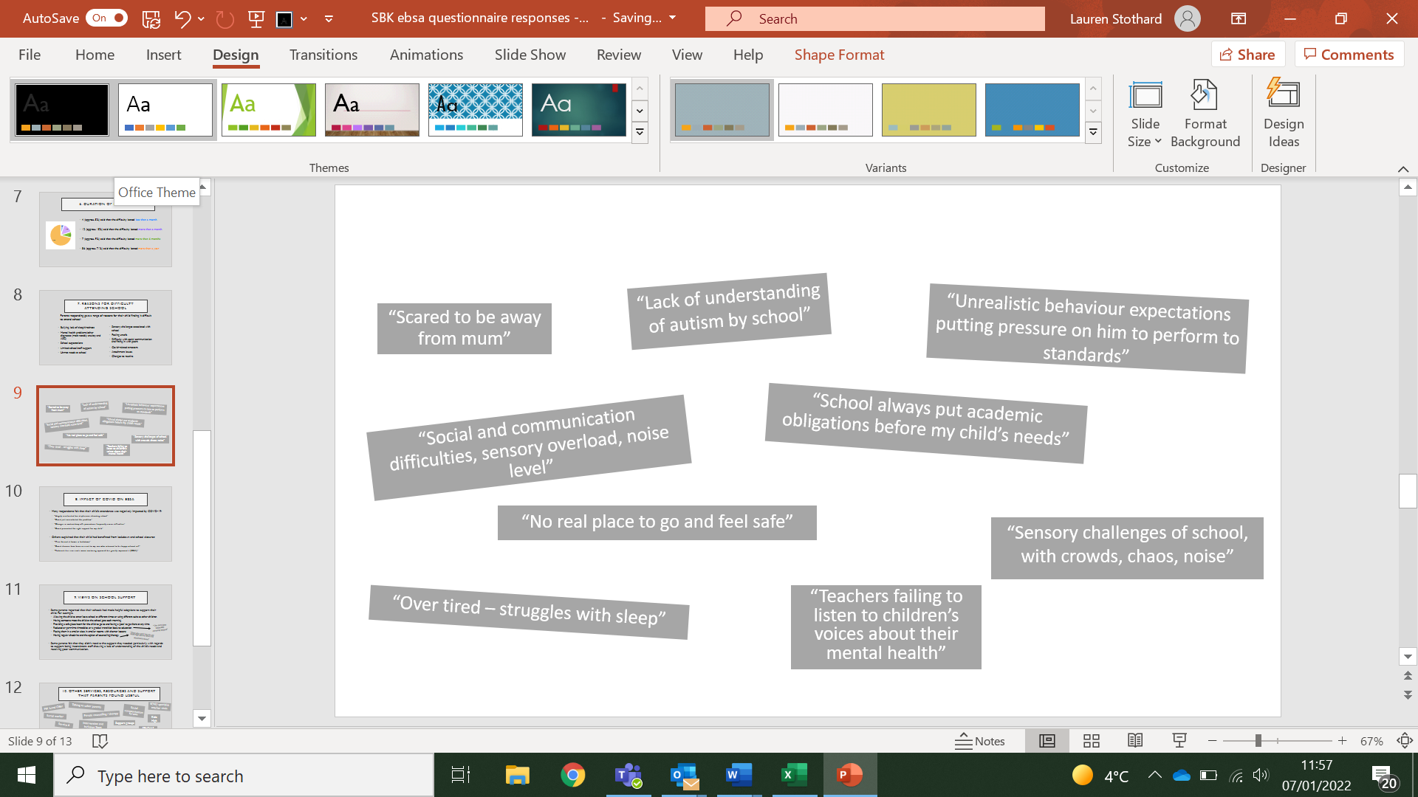

* Some parents reported that their schools had made helpful adaptions to support their child. For example,
  + Allowing the child to enter/leave school at different times or using different exits as other children
  + Having someone meet the child at the school gate each morning
  + Providing a safe place/room for the child to go to and having a ‘pass’ to go there at any time
  + Reduced or part-time timetables, or a gradual transition back to education
  + Placing them in a smaller class, in smaller rooms, with shorter lessons
  + Having regular check-ins and the option of counselling/therapy
* Some parents felt that they didn’t receive the support they needed, particularly with regards to support being inconsistent, staff showing a lack of understanding of the child’s needs and receiving poor communication.

“The part-time timetable certainly helped”

“They also sent him on the Ride High course which he absolutely loved”

9. views on school support

11. How support/ information could be improved

Suggestions from parents:

* More offers of support and advice
* Relationships (to build trust) and consistency with teaching staff
* Increased support for bullying, whilst encouraging friendships
* Better communication between home and school, and young person and school
* Planning and monitoring children’s progress
* Enhanced awareness, understanding and training e.g., for EBSA, ASD, child mental health
* Support for parents, including less parent-blaming 🡪 parental mental health also impacted
* Disorder-related behaviours should not be punished; children should not be excluded
* More flexible, person-centred education e.g., part-time, shorter school day, brain breaks
* Seeing their child as an individual, respecting and listening to them
* One-to-one teaching

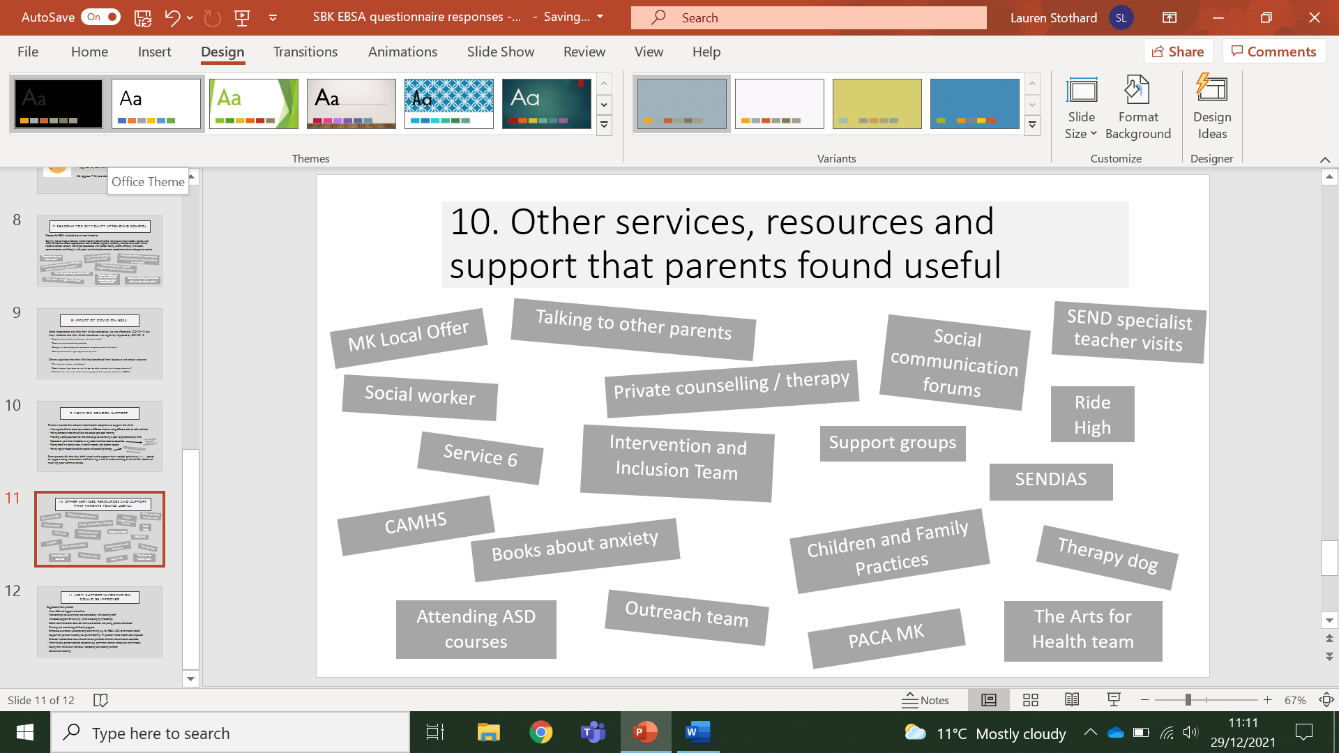

10. Other services, resources and support that parents found useful