**Emotionally Based School Avoidance (EBSA)- Guidance for Schools and Settings in Milton Keynes**

Part One: Information







**Contents**

|  |  |
| --- | --- |
| Introduction | 3 |
| What is EBSA? | 4 |
| Factors Contributing to EBSA | 5 |
| Anxiety & EBSA | 10 |
| Milton Keynes Approach to Support | 11 |
| Milton Keynes Four Stage Model:  Identify  Assess  Plan-Do-Review  Approaches to Support | 11  12  14  15  17 |
| References | 19 |

**Please note, this guidance is intended to be read and used in conjunction with the following document:**

Emotionally Based School Avoidance (EBSA) Guidance for Schools and Settings in Milton Keynes- Part Two: Practical Support

**Introduction**

Attending school on a regular basis not only supports academic attainment, but is also important for the development of key life skills and the development of children and young people as citizens (Pellegrini, 2007). Research has shown that children with poor attendance are less likely to succeed academically at both primary and secondary school, and are more likely to not be in education, employment or training when they leave school (Department for Education, 2018; 2020). Persistent patterns of non-attendance over time are also associated with reduced future aspirations, poor emotional regulation, low self-esteem, social-emotional development, and mental health difficulties (Lee, 2019; Gregory & Purcell, 2014; Flakierska-Praquin et al, 1997).

Although it is difficult to predict the prevalence of Emotionally Based School Avoidance (EBSA), available research estimates it impacts 1-5% of the school population (Pellegrini, 2007; Elliott & Place, 2019). Local data collected across Autumn and Spring Terms (2021-22) indicates that the number of children impacted in Milton Keynes is consistent with this.

In line with national good practice, the Milton Keynes approach to supporting children and young people who experience EBSA is underpinned by the following principles associated with positive outcomes:

* Early intervention
* Collaborative, person-centred working- working with parents and schools, as well as the young person
* Understanding individual needs and contexts
* Emphasis on the need for a rapid return to the educational setting alongside support and adaptations within the school and home environment

The Milton Keynes EBSA Guidance comprises two parts: Information and Practical Support. Both parts aim to draw upon evidence-based theory and practice to provide useful guidance for schools, parents and other professionals when supporting children and young people who experience EBSA.

The guidance documents have been developed by Milton Keynes Educational Psychology Service in conjunction with the MK EBSA working group, and are intended to complement the introduction of a joined-up MK EBSA Support Pathway.

There has already been a lot of excellent development work in this area from colleagues across the educational psychology profession, and the current guidance draws heavily upon this. Particular appreciation and warm thanks are given to the following Educational Psychology Services: West Sussex, Solihull, and Staffordshire.

Both parts of the guidance and any relevant resources can be found in the ‘Resources’ section of the Milton Keynes Educational Psychology Service website: [www.milton-keynes.gov.uk/educational-psychology-service](http://www.milton-keynes.gov.uk/educational-psychology-service)

**What is EBSA?**

Emotionally Based School Avoidance (EBSA) is a, ‘broad umbrella term used to describe a group of children and young people who have a severe difficulty in attending school due to emotional factors, often resulting in prolonged absences from school’ (West Sussex Educational Psychology Service, 2018).

There are other terms for EBSA used across the literature, including school refusal, school non-attendance; school withdrawal; and school phobia. However, EBSA is adopted for the purpose of this guidance as it does not automatically assume a within-child view of the behaviour, widening the possibilities for change (Lee, 2019). Research also makes a clear distinction between non-attendance at school due to truanting and EBSA, where absence is generally with parental knowledge and due to specific emotional distress associated with attending school (Thambirajah et al, 2008).

EBSA can present differently across individuals, but can include one, or a combination of, the following: fear and anxiety (including physical symptoms), misery, complaints of feeling ill without obvious cause, reluctance to leave home, tantrums, and/or oppositional behaviour.

The onset of EBSA can occur suddenly or develop gradually over time. Thambirajah et al (2008) also considers that EBSA behaviours can occur on a spectrum, ranging from occasional reluctance to attend school to complete avoidance resulting in persistent non-attendance.

Research shows that the prevalence of prolonged absences is greater around times of transition from one educational setting into another. This is true for all phase changes at:

* Home to infant school
* Junior school entry
* Secondary school transition and
* Leaving school to go to college

Many children find the transition to secondary school particularly difficult as many changes are occurring (developmental, environmental and organisational). The emotional impact of moving from a relatively protective environment, where often one key adult was responsible for ensuring your welfare, into a larger often unfamiliar organisation where the student is faced with learning how to navigate around the school, organise their books and workload as well as make new social relationships, can be very daunting, particularly for children already feeling vulnerable.

Rice et al (2011) reported that children who were concerned about the secondary transfer tended to view aspects of school negatively, displayed greater anxiety, felt pessimistic about the change, experienced low moods and already had social relationship issues.

The majority of children adapt well to transition, but for those who don’t, key factors need to be identified to reduce the risk of school refusal.

**Factors Contributing to EBSA**

Children and young people experiencing EBSA are not a homogenous group. It is widely recognised that the reasons are often complex and multi-faceted; and include environmental factors present at home and school, as well as individual child factors.

Purcell and Tsverik (2008) gathered the views of children and young people experiencing anxiety-based school attendance issues. The key themes which came out of the interviews were:

* + the overall school experience
  + fear of certain teachers
  + social isolation
  + experiences of bullying
  + social difficulties (which affected the ability to build positive social relationships)
  + disaffection with education
  + a lack of discipline
  + attendance at many different schools from a young age created problems

It is important to acknowledge that any factors identified are unlikely to be static and unchanging; that what led to the initial school avoidance, may not necessarily be what continues to maintain the persistent avoidance; and that what appears to be the cause of the issue may in fact be the consequence.

Research suggests that the key overarching factors influencing EBSA include:

3. ‘Push’ and ‘Pull’ factors (Thambirajah et al, 2008)

1. Functions of school non- attendance

2. Risk and resilience factors

1. **Functions of School Non-Attendance**

Staffordshire EPS (2020) highlighted the importance of thinking about what unmet need/s avoiding school fulfils for the child or young person, as well as what the non-attendance is communicating in terms of expressing feelings or unmet needs. They suggest consideration of the following questions:

* Avoiding school is the solution to what problem for the CYP?
* What outcome is the CYP’s non-attendance achieving for them?
* What are the CYP’s non- attendance behaviours telling us about how they are feeling?
* What are the CYP’s non-attendance behaviours telling us about what they need?

Kearney & Silverman (1993) identified four main functions considered to underpin school avoidance behaviours. These are detailed in the table below, along with examples:

|  |  |
| --- | --- |
| **Functions of school non-attendance** | |
| **To avoid uncomfortable feelings brought on by school** e.g. anxiety or low mood; feelings of disconnection/not belonging | **To avoid situations that might be stressfu**l e.g. academic demands; exams/evaluations; social pressures/interactions that are challenging; breaktimes/lunchtimes; aspects of the school environment, including noise, crowds, buildings or classrooms; transitions |
| **To reduce separation anxiety or gain attention from significant others** e.g. time at home with parents/carers/family members | **To engage in preferred activities** e.g. watching TV, playing video games, spending time with friends, going shopping |

Table 1. Functions of School Non-Attendance- Adapted from Staffordshire EPS (2020) and West Sussex (2018)

1. **Risk and Resilience Factors**

Research has identified a range of contributing ‘risk’ factors to EBSA. West Sussex EPS note that it is often a combination or predisposing factors (in school, family and/or child) interacting with a change of circumstances that leads to EBSA behaviours.

|  |  |  |
| --- | --- | --- |
| **Contributing ‘Risk’ Factors** | | |
| **School Factors** | **Family Factors** | **Child Factors** |
| Bullying (the most common factor)  Difficulties in specific subject  Transition to secondary school, key state or change of school  Structure of the school day  Academic demands/high level of pressure and performance-orientated classrooms  Ineffective SEN provision  Activities that the child or young person cannot manage (e.g. PE, performing in public)  Transport or journey to school  Exams  Peer or staff relationships difficulties | Separation and divorce or change in family dynamic  Parent physical or mental health problems  Siblings at home e.g. home educated or due to health needs  Overprotective parenting style  Dysfunctional family interactions  Being the youngest child in the family  Loss and bereavement  High levels of family stress  Family history of EBSA  Young carer responsibilities | Temperamental style- reluctance to interact and withdrawal from unfamiliar settings, people or objects  Challenges with emotional self-awareness and self-regulation  Fear of failure and poor self-confidence  Physical illness  Age (5-6, 11-12 and 13 and 14)  Learning difficulties, developmental problems or Autistic Spectrum Condition if unidentified or unsupported  Anxiety interacting with peers  Separation anxiety from parent/worry parent will leave/worry about parent wellbeing  Traumatic events |

Table 2. Taken from West Sussex EPS (2018), Thambirajah et al (2008) and Staffordshire EPS (2020)

When supporting children and young people experiencing EBSA it is also important to think about the areas of strength and sources of resilience available to them. These can serve to protect a CYP from maintaining EBSA behaviours and promote successful inclusion in school. Again, these have been divided into school, family and child factors below.

|  |  |  |
| --- | --- | --- |
| **Resilience Factors** | | |
| **School Factors** | **Family Factors** | **Child Factors** |
| Positive relationships with a member/s of staff  Willingness to work in partnership with family and support agencies  Positive relationships with peers  Experiencing success in school  Having a flexible approach  Developing understanding of the child or young person’s feelings | Positive relationships in the family and/or community  Willingness to work in partnership with school and support agencies  Positive parenting skills  Developing understanding of the child or young person’s needs | Individual strengths and interests  Developing ambition and aspiration  Motivation for change  Increasing confidence, self-esteem, self-efficacy and value in themselves |

Table 3. Taken from Staffordshire EPS (2020)

1. **‘Push’ and ‘Pull’ Factors**

Contributory factors to EBSA can also be understood in terms of ‘push’ and ‘pull’ factors. These are conceptualised in slightly different ways across the literature. However, for the purpose of this guidance, the following definitions are used (from Nuttall & Woods, 2013).

* Push factors- those that push the child AWAY from school
* Pull factors- those that pull the child TOWARDS home



For example, a child may be PUSHED away from school following a transition, due to difficulty adjusting to a new environment, difficult relationships with staff and difficulty accessing learning. The same child may be PULLED towards home by the wish to look after a parent who has a long-term health condition.

According to Thambirajah et al (2008, p33), EBSA, ‘occurs when stress exceeds support, when risks are greater than resilience and when ‘pull’ factors that promote (EBSA) overcome the ‘push’ factors that encourage attendance’.

**Anxiety & EBSA**

Anxiety is considered to be a key feature of EBSA (Pellegrini, 2017; Lee, 2019). Anxiety is a normal part of life. However, some children and young people experience such heightened levels of anxiety that it negatively impacts their ability to attend and cope in school. For some children and young people anxious thoughts can also be accompanied by physical symptoms i.e. nausea, vomiting, shaking, sweating, heavy/fast breathing and panic attacks.

Our para-sympathetic nervous system is designed to respond to potential threats and prepare us for fight, flight or freeze. People who suffer from anxiety have often not learnt to manage their emotional reactions to stress. Without appropriate strategies the anxiety can feel as though it is increasing, growing and beginning to overwhelm the young person. They then turn to the adults around them to seek support in managing and containing the emotions. Humans often project their feelings onto others; therefore an anxious child can provoke anxiety in those around them. If a child senses that the adults do not know what to do, that can increase the anxiety.

When anxiety is linked to school avoidance, this can lead to a vicious cycle which can reinforce and maintain EBSA over time (see Figure 1). For example, when a young person avoids school, this can instantly reduce anxiety and reinforce the idea that missing school is a good strategy to avoid negative feelings. Prolonged time out of school can also lead to secondary maintenance factors. For example, missing school means that young people will miss out on schoolwork and social opportunities with peers, which means that it can be even more difficult to return to school.

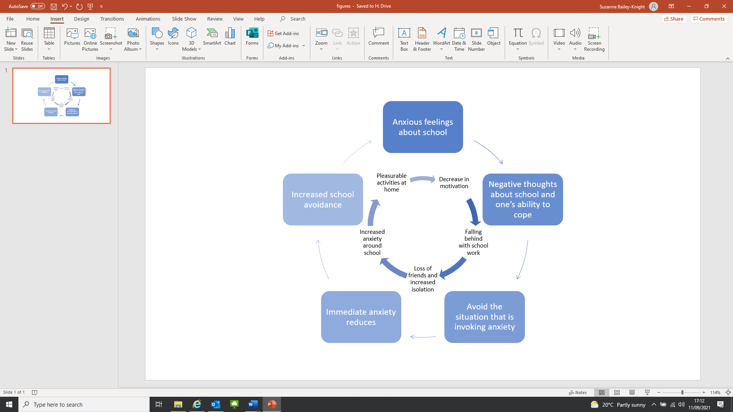

Figure 1. Taken from ‘Emotionally Based School Avoidance: Good Practice Guidance for Schools and Support Agencies’ West Sussex EPS, 2018

**The Milton Keynes Approach to Support**

In line with good practice, a graduated approach to responding to EBSA is promoted in Milton Keynes. This enables children and young people to receive support from those who know them best at home and school, and who will be working with them regularly. This staged approach is reflected in the detailed local pathway currently in development.

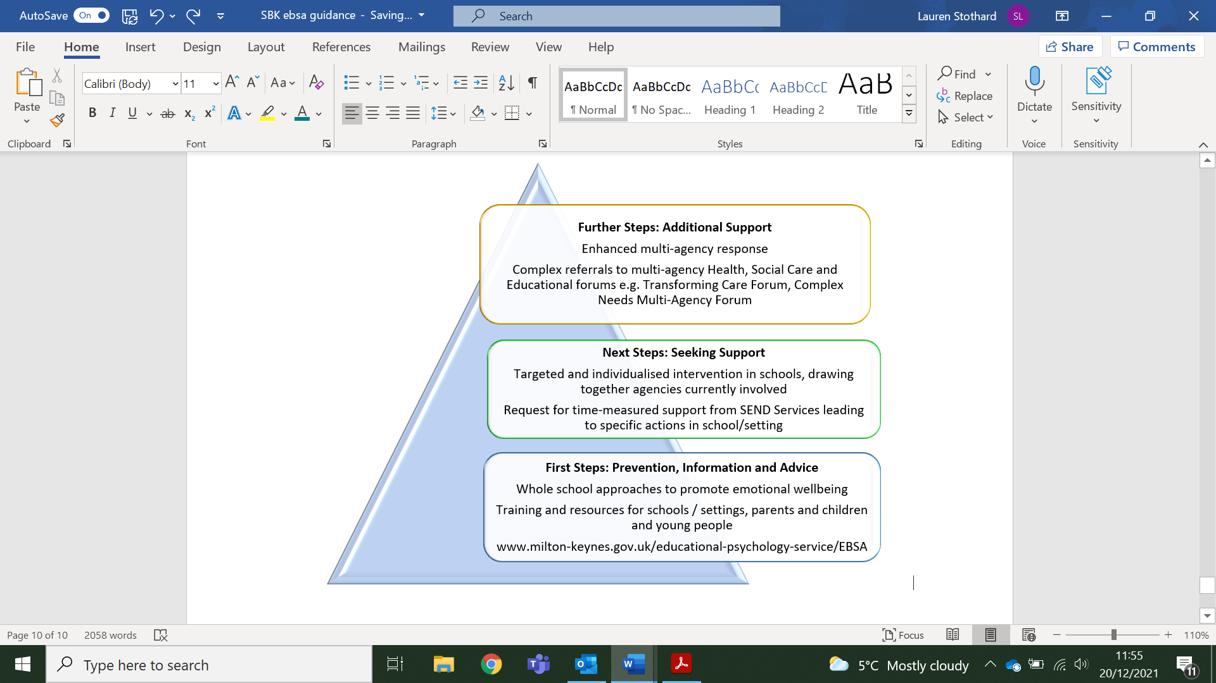

Figure 2. The MK EBSA graduated approach, adapted from Solihull Community Educational Psychology Service & Solar (2020)

When supporting individual children and young people, the following four evidence-based stages of response should be considered at all stages of involvement.

Figure 3. The Milton Keynes 4 stage model

**Identify**

It is very important that children and young people who are experiencing EBSA, or who are at risk of EBSA, are identified early. The longer EBSA remains unaddressed, the poorer the outcomes as the issue can become entrenched (West Sussex EPS, 2018).

In addition to their usual attendance monitoring systems, schools should remain mindful of possible risk factors present for individual children and young people (see ‘Factors Contributing to EBSA’ section above). The Practical Support Document (p5-12) includes some useful tools to identify children and young people who may be at risk of EBSA.

In order to recognise the possible indicators of EBSA, it is important that schools and other professionals remain curious about children and young people’s behaviour, try to refrain from making assumptions, and share information with colleagues to establish a holistic picture. Where concerns are identified, it will be important to gather further information and explore with the child or young person, parent and school staff, as soon as possible (see Assess section below).

Common features of EBSA are included in the table below:

|  |
| --- |
| **Early Indicators of EBSA** |
| Sporadic attendance and/lateness  Parent reporting that CYP does not want to come into school  Physical signs of stress believed to be linked to stress (e.g. stomach ache, sickness, headache) or complaining of being ill  Behavioural changes or fluctuations e.g. interactions with others, reduced motivation and engagement in learning tasks |
| **Indicators of EBSA** |
| Periods of prolonged absence  Persistent lateness  Parent/carer unable to support CYP to attend school  Identifiable patterns of within school non-attendance e.g. specific days, subjects, staff members  Providing minor reasons for school absences  CYP experiences anxiety in relation to home factors e.g. parental separation, divorce, conflict, loss, bereavement  CYP displays greater reliance upon family members e.g. separation anxiety, increased proximity  Concerns around academic progress due to school non-attendance/missed education  CYP displays increased anxiety in relation to their learning and/or poor self-concept as a learner  Low self-esteem and/or lack of confidence  Struggling in relation to peer relationships and/or social situations  Physical signs of stress believed to be linked to stress (e.g. stomach ache, sickness, headache) or complaining of feeling ill  Displays of emotional dysregulation and/or distress |

Table 4. Taken from Solihull Community Educational Psychology Service & Solar (2020): Collaborative working to promote attendance and Psychological wellbeing

**Assess**

Where significant risks of EBSA are identified, it is important to gather further information to gain understanding of the child, family and school factors that may be contributing to or maintaining the EBSA behaviours. Detailed assessment allows for a formulation to be developed to inform a tailored intervention plan. Thambirajah et al (2008, p71) state that, ‘it is essential to make an integrated formulation of the problem before embarking on interventions’.

As outlined earlier, although it can be tempting to try and find one simple reason for the EBSA behaviour, the reasons are often complex and multi-faceted. West Sussex EPS states that, ‘trying to find simple causation often encourages blaming and individuals can then become anxious and defensive’ (West Sussex, 2018). Parents can feel blamed and children and young people can feel guilty or fearful, which may act as a barrier to their engagement in the support process.

Any assessment should aim to explore the unique perspectives of all by gaining the views of the child or young person, parent/carer, and school staff.

Assessment should also explore the following areas:

* The child or young person’s strengths
* Developmental and family history
* Possible functions of school non-attendance for the child or young person
* Risk and resilience factors present
* Any ‘push’ and ‘pull’ factors present

Factors to consider when working with children and young people and parents/carers are included on p14 and p20 respectively of the Practical Support document. Due to the nature of EBSA, there cannot be one way to complete the assessment. However, a range of assessment tools and approaches which schools may find useful are also included from p14 of Practical Support document.

**Plan-Do-Review**

Once further information has been collected, it is important to draw it together to ‘make sense’ of it. A formulation about what could be underpinning the EBSA behaviours should be developed so that a shared understanding of the key issues can be established. This should inform the support plan developed and approaches used. Nuttall & Woods (2013) assert that in order to successfully reduce EBSA behaviour, all relevant systems must be taken into account when intervention planning.

Support plans should be written in collaboration with the child or young person, parent/carer and other professionals involved. All parties need to sign up to what is agreed. In addition, support plans should:

* Be person-centred
* Plan for a gradual and graded re-integration – a part time timetable may be appropriate in the short term
* Link clearly to the factors identified as contributing to EBSA, and plan to intervene at both the school and home levels
* Detail the strategies and approaches that will support the child or young person achieve the outcomes set
* Be realistic - an overly ambitious plan is likely to fail
* Break down larger goals into small, achievable steps
* Be clear about roles and responsibilities
* Include review dates

Templates and example plans can be found in the Practical Support document, from p46.

In addition to this, the following important considerations should be taken into account when planning and reviewing support:

* Prepare to take a flexible and individual approach.
* Recognise that what has worked for one pupil will not necessarily work for another
* Anticipate that there may be ‘bumps’ in implementing the plan and include a commitment to finding solutions when that happens
* Recognise that the child/young person is likely to be more unsettled at the beginning of the plan, and that school and parent/carers need to work together to show a consistent approach.
* Keep optimistic- if a child/young person does not attend on a day as planned, start again the next day
* Any concerns about the process should not be shared in front of the child or young person, a ‘united front’ is recommended. Concerns should be communicated away from the child/young person.
* All school staff that the child/young person will come into contact with should be aware of the plan.
* Be consistent and follow through on agreements till the end. For example, don’t be tempted to move the goalposts if the child/young person is doing better than expected. This can reduce trust. Wait until the next review point to make changes.

It is essential that plans are reviewed regularly, and that all stakeholders are involved in the review process. Reviews should consider what has worked well, what should be continued, and what needs to be adjusted.

In line with good practice, a continuous Assess, Plan, Do, Review cycle should be followed (see Figure 4 below), with information gathered as part of reviews feeding into the ongoing assessment process. It is important to acknowledge that initial formulations may need to be revised or discarded as new information arises. Following the wider MK Approach to Support model (Figure 2), parties may also consider that further support is needed as a result of reviews over time.

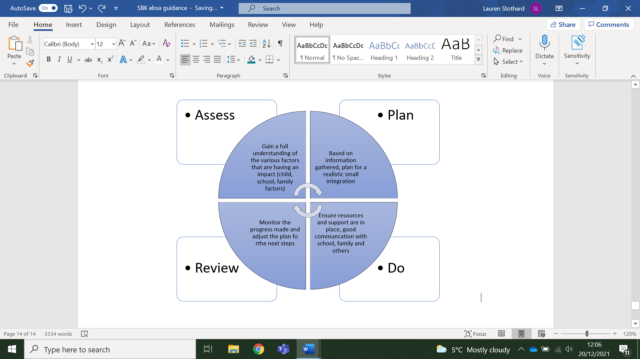

Figure 4. EBSA Assess-Plan-Do-Review process

**Approaches to Support**

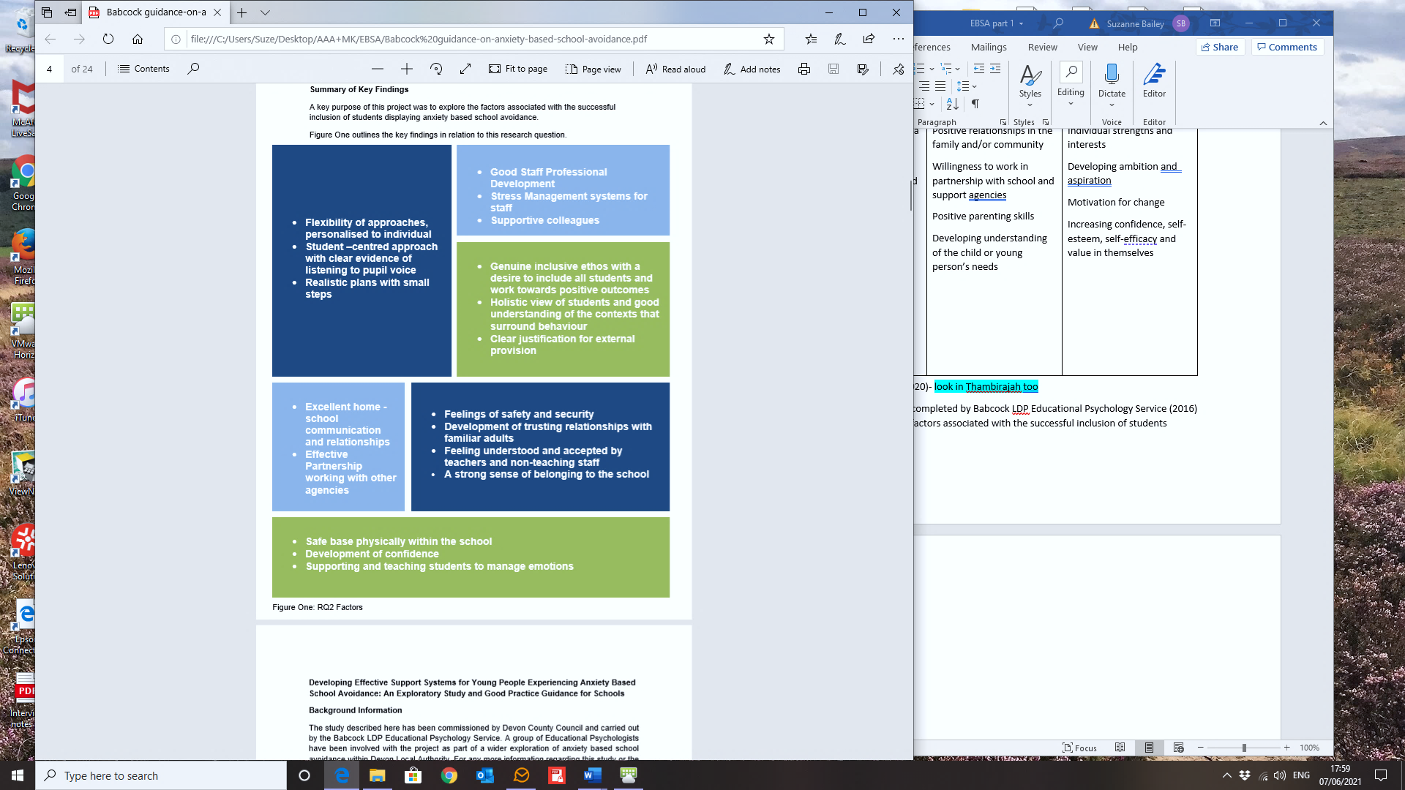Oxfordshire Educational Psychology Service (2020) identify three key elements from the literature to helping children return to school after a period of prolonged absence: relationships; agency and control; and practical support. These are reflected in research completed by Babcock LDP Educational Psychology Service (2016) who identified a number of key approaches associated with the successful inclusion of students experiencing EBSA (see Figure 5. below).

Figure 5. Taken from ‘Developing Effective Support Systems for Young People Experiencing Anxiety Based School Avoidance: An Exploratory Study and Good Practice Guidance for Schools (Babcock LDP EPS, 2016)

The above indicates that a mixture of whole school, family and individual approaches need to be considered within any package of support.

Adopting a whole-school approach to promoting good mental health has been identified as a protective factor for child and adolescent mental health (Public Health England, 2021). The Department of Education and the National Institute of Care Excellence both advocate for comprehensive whole school approaches to promoting the social and emotional wellbeing for children and young people across educational settings (Public Health England, 2021).

Public Health England (2021) identified the following eight principles to promote a whole school and college approach to emotional health and wellbeing:

Figure 6. Taken from ‘Promoting children and young people’s emotional health and wellbeing – a whole school and college approach’ (Public Health England, 2021)

Whole-school audit tools can be found from p71 of the Practical Support document.

These general principles of supporting wellbeing and mental health all apply to children and young people experiencing EBSA, and are reflective of many of the key approaches associated with the successful inclusion of students experiencing EBSA outlined in Figure 5 above. Furthermore, ‘any successful work with an individual needs to be embedded in whole school systems’ (West Sussex EPS, 2018, p26).

Individual strategies should be directly informed by the assessment completed, and tailored to the specific child/young person and wider context. What works for one child/young person, may not work for another. The Practical Support document contains some examples of useful strategies linked to common areas of difficulty (from p50).

**References**

Babcock LDP Educational Psychology Service (2016). *Developing Effective Support Systems for Young People Experiencing Anxiety Based School Avoidance: An Exploratory Study and Good Practice Guidance for Schools*. Babcock LDP and Devon County Council.

Department for Education (2018). *Characteristics of young people who are long-term NEET*. <https://assets.publishing.service.gov.uk/government/uploads/system/uploads/attachment_data/file/679535/Characteristics_of_young_people_who_are_long_term_NEET.pdf>

Department for Education (2020). *School Attendance: Guidance for maintained schools, academies, independent schools and local authorities.* <https://assets.publishing.service.gov.uk/government/uploads/system/uploads/attachment_data/file/1039223/School_attendance_guidance_for_2021_to_2022_academic_year.pdf>

Elliott, J. G., & Place, M. (2019). Practitioner review: school refusal: developments in conceptualisation and treatment since 2000. *Journal of Child Psychology and Psychiatry*, *60*(1), 4-15.

Flakierska-Praquin, N., Lindström, M., & Gillberg, C. (1997). School phobia with separation anxiety disorder: A comparative 20-to 29-year follow-up study of 35 school refusers. *Comprehensive Psychiatry*, *38*(1), 17-22.

Gregory, I. R., & Purcell, A. (2014). Extended school non-attenders’ views: Developing best practice. *Educational Psychology in Practice*, *30*(1), 37-50.

Kearney, C. A., & Silverman, W. K. (1993). Measuring the function of school refusal behavior: The School Refusal Assessment Scale. *Journal of Clinical Child Psychology*, *22*(1), 85-96.

Lee, H. (2019). The Use of Cognitive Behavioural Therapy for School Refusal Behaviour in Educational Psychology Practice. *Educational Psychology Research and Practice*, *5*(2), 1-13.

Nuttall, C., & Woods, K. (2013). Effective intervention for school refusal behaviour. *Educational Psychology in Practice*, *29*(4), 347-366.

Oxfordshire County Council (2020). *Emotionally-based school avoidance (EBSA)- COVID-19 Intervention timeline.*

Pellegrini, D. W. (2007). School non‐attendance: Definitions, meanings, responses, interventions. *Educational Psychology in Practice*, *23*(1), 63-77.

Public Health England (2021). *Promoting children and young people’s emotional health and wellbeing- A whole school and college approach*. <https://www.gov.uk/government/publications/promoting-children-and-young-peoples-emotional-health-and-wellbeing>

Purcell, A., & Tsverik, I. R. (2008). Extended school non-attenders’ views: developing best practice within an Educational Psychology Service. *North Somerset Educational Psychology Service*.

Rice, F., Frederickson, N., & Seymour, J. (2011). Assessing pupil concerns about transition to secondary school. *British journal of educational psychology*, *81*(2), 244-263.

Solihull Community Educational Psychology Service & Solar (2020). *Collaboratively working to promote Attendance and Psychological Wellbeing*. Solihull Metropolitan Borough Council and Solar- Brightening Yong Futures.

Staffordshire Educational Psychology Service (2020). *Emotionally Based School Avoidance: Guidance for Educational Settings.* Staffordshire County Council.

Thambirajah, M. S., Grandison, K. J., & De-Hayes, L. (2008). *Understanding school refusal: A handbook for professionals in education, health and social care*. Jessica Kingsley Publishers.

West Sussex Educational Psychology Service (2018). *Emotionally Based School Avoidance: Good practice guidance for schools and support agencies.* West Sussex County Council.