

SEND Centralised Training Offer for Schools and Settings



Together we support and empower children and young people with SEND to live well, learn well, and lead happy and fulfilling lives.

Academic year 2026-2027

Our Vision Statement
Together we support and empower children and young people with SEND to live well, learn well, and lead happy and fulfilling lives.
We are thrilled to share with you our 2026-27 Centralised Training offer to schools and settings in Milton Keynes. We have worked hard with our stakeholders and carefully considered feedback from school leaders to create an offer which fits purpose and is appropriate to the needs of our children and young people in Milton Keynes.
Our co-production values aim to be a ‘golden thread’ running through all SEND Strategy activities and are integral to our partnership working across education, health and care. Therefore, we have ensured that our offer includes sessions from our SALT, Educational Psychologists and Healthcare colleagues.
Sessions will be offered either face to face or via TEAMS; the course will also outline if this is a webinar-based session (information giving) or an interactive session (opportunities for discussion).
Courses are organised into the four areas of need and inclusion:
- Social Communication and Interaction
- Cognition and Learning
- Emotional and Social Wellbeing and Mental Health
- Physical and Sensory
- Inclusion
This is the first draft of the document, and courses will continue to be added at different points in the year. Updated editions of the document will be shared via the Local Offer pages.
We also strongly encourage SENCOs to attend the regular SENCO Quadrant Meetings to receive the latest updates from the MKC SEND Team, supporting external agencies, local organisations supporting SEND, and national initiatives and policy.
MKC colleagues are able to attend sessions where relevant to their work and where numbers can accommodate the request.

How to enroll on a course
Please use the new booking system to book and manage training sessions. This is located on the Centralised Training page on the Local Offer.
Use the ‘How to book and manage the Centralised Training offer’ for a more detailed step by step guide. Located on the Centralised Training page on the Local Offer.
Quick Guide:
To access the new booking system, you will need to register and create an account with MK Council.
- Visit the MyCouncil Website https://mycouncil.milton-keynes.gov.uk/

If you already have an account with MK Council, you will need to log in and then:
- Load the Enrolment Form with one of the options below.
- Click on the link https://mycouncil.milton-keynes.gov.uk/service/Centralised_Training___Enrolment
- Copy and paste the link https://mycouncil.milton-keynes.gov.uk/service/Centralised_Training___Enrolment into the url address bar.

- If you are already logged in to the MyCouncil site, the Enrolment Form will load.

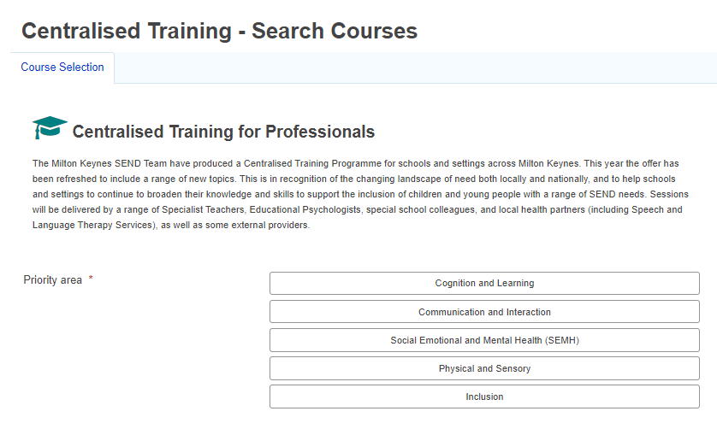

Email confirmation of training
You will be sent an email confirmation of the session(S) you have booked, and you will have the option to cancel following the link on the email booking. Please note that only the staff member who has booked the training will be able to manage the bookings.
Other staff you have booked onto the training will also receive an email confirmation, but they will not be able to manage their booking.

How to manage your bookings
Log onto your MK council account as above to manage your bookings (As above).
Go the ‘Requests’ on the tab:
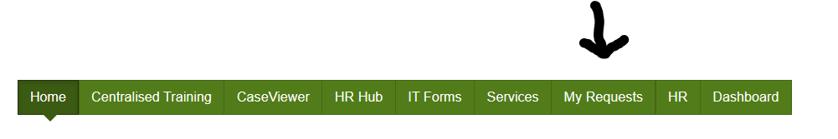
Please refer to the ‘How to book and manage the Centralised Training offer’ for a step-by-step guide.
You can still email: SENDtraining@milton-keynes.gov.uk for queries.
Course Evaluation
We ask everyone to complete an evaluation form at the end of training sessions using a link shared via the MS Team invite. Following completion of the evaluation any relevant resources will be sent out.
We take your feedback about training very seriously and your remarks will guide us when planning future training.

CPD Programme in schools
SENDCO’s and Leaders to consider how the resources below can be used to create a CPD programme which can be planned throughout your year and be implemented into your INSET days/team meetings.
Dyslexia: The Dyslexia-SpLD Trust - Home
Free whole school SEND CPD: Whole School SEND Home Page | Whole School SEND
Occupational Therapy resources: Milton Keynes Children and Young People's Occupational Therapy Team :: Central and North West London NHS Foundation Trust (cnwl.nhs.uk)
SALT resources: Milton Keynes Children’s Speech and Language Therapy Services :: Central and North West London NHS Foundation Trust (cnwl.nhs.uk)
MK SEND Video Resources: Parent and carer programmes | Milton Keynes City Council (mksendlocaloffer.co.uk)

Cognition and Learning

Course title | Date and time | Delivery method | Delivered by: | Suitable for:
Precision Teaching | Two part training  Session 1: 04/02/27  2- 3.30pm  Session 2:  11/03/27  2- 3.30pm | MS TEAMS  (NB should attend both sessions) | Educational Psychology Service | Primary and Secondary
Literacy: The skills needed for effective reading and writing | 20/01/27  2-4pm | Face to Face Civic | Educational Psychology Service | Primary and Secondary
Executive Functioning | Thursday 14/01/27  2 - 4pm | Face to Face Civic | Educational Psychology Service | All ages
Supporting Numeracy: What teaching assistants can do to enable effective learning. | 11/02/27  2-4pm | Face to Face  Civic | Educational Psychology Service | Primary and Secondary

Emotional and Social Wellbeing and Mental Health

Course title | Date and time | Delivery method | Delivered by: | Suitable for:
ARFID Awareness: Understanding, Recognising and Supporting Children and Young People in Education | 17/06/27  1-3pm | Face to Face  Civic 1.25 | Educational Psychology Service | Primary & Secondary

Inclusion and Statutory Processes

Course title | Date and time | Delivery method | Delivered by: | Suitable for:
Gaining Pupil Voice | 04/03/2026  2pm-4pm | Face to face | Educational Psychology Service | Primary and Secondary
OAP: Stories of implementation  Cohort 2  Session 1 | 24/11/26  1.30 - 3.30pm | TEAMS | Specialist Teaching Team | Primary & Secondary
Role of the Early Years SENCO | Friday 13th and Friday 20th Nov 9-11.30am | Face to Face  Civic 1.26 | Inclusion Practitioners | Early Years Settings
New to the role of SENCO | September – Wednesday 30th 2-3.30pm  October - Wednesday 21st 2-3.30pm  November - Wednesday 18th 2-3.30pm  December – Wednesday 16th 2-3.00pm  January - Wednesday 13th 2-3.30pm  February - Wednesday 10th 2-3.30pm  March - Wednesday 17th 2-3.30pm  April – Wednesday 28th 2-3.30pm  May – Wednesday 19th 2-3.30pm  June – Wednesday 9th 2-3.30pm  July - Wednesday 30th 2-3.00pm | TEAMS | Specialist Teaching Team | Primary & Secondary

Cognition and Learning

Precision Teaching
Course Summary
Precision Teaching is a structured approach used to develop and monitor literacy and numeracy skills. Rather than being a standalone intervention, it provides a framework for planning, monitoring and evaluating targeted teaching.
Precision Teaching is typically delivered for 10–15 minutes each day, with a focus on developing both accuracy and fluency in a specific skill. It is based on the principle that all children can make progress when teaching is carefully matched to their needs. Progress is monitored regularly so that teaching can be adapted in response to the pupil’s learning.
The training also introduces a reading skills assessment, which can be used to develop a profile of a pupil’s strengths and areas of difficulty across the different skills involved in reading. This supports schools to identify appropriate targets, plan intervention and gather evidence of progress over time.
The course is delivered across two sessions, allowing participants time between sessions to set up and begin using Precision Teaching in their setting.
- Session 1 focuses on using Precision Teaching to develop reading skills and draws on approaches developed by Warwickshire and Staffordshire Educational Psychology Services.
- Session 2 explores how Precision Teaching can be applied to other areas, including maths, and provides an opportunity to consolidate learning, share experiences and troubleshoot any difficulties encountered in practice.
Participants can also contact the trainer between sessions to ask questions to support their implementation of Precision Teaching.
Lead Trainer: Dr Chelsea Levinson-Obank, Educational Psychologist
Course dates and times:
- Thursday 04 February 2027, 2:00–3:30pm
- Thursday 11 March 2027, 2:00–3:30pm
Venue:
Remote training via Microsoft Teams
Who should attend?
- The course is suitable for staff working with primary- and secondary-aged pupils.
- To gain the most from the practical activities, schools are encouraged to send two members of staff, for example a teacher and teaching assistant, and/or the school SENCO.
- Attendance at both sessions is required. The time between sessions enables participants to set up and begin delivering the intervention, so that Session 2 can be used to reflect on implementation, ask questions and consolidate learning.

Cognition and Learning
Literacy: The skills needed for effective reading and writing
Course summary:
In this training we will explore the skills needed for children to become literate. We will look at the most effective ways of supporting children to acquire the skills they need and how to help them to apply and develop their skills in meaningful contexts.

Trainers: Delivered by colleagues in the Educational Psychology Service

Course content:
This training will cover:
- Why is reading important
- How children learn to read
- How to promote reading attainment and engagement

The session will involve elements of group activities and discussions.

Course dates and time:
20th January 2027 at 2-4pm

Venue: Civic Offices Room: TBC

Who should attend?
This course is useful for SENDCos and teaching/learning assistants in key stage 1 and 2 in a mainstream setting who work with children who are finding it difficult to make progress in Literacy.

Cognition and Learning

Executive Function: understanding and supporting difficulties in school.
This training will provide an overview to the concept of Executive Function (EF) as well as practical tools and ideas on how to support children and young people. It will involve elements of discussion, practical work and group activities.
Course summary:
Executive dysfunction is a challenge that affects a student’s ability to focus their attention, manage tasks, stay organized, and regulate their emotions and behaviour. These are all critical skills for academic success and reaching longer term goals. EF skills impact nearly every aspect of a student’s school experience, from managing impulses, keeping track of assignments, focusing in class and managing time effectively. For many students, these challenges can be overwhelming, leading to missed deadlines, incomplete work, procrastination, and frustration.
In this training we will explore:
- What Executive Function is, and the skills involved
- The relationship between EF skills, learning and behaviour
- How to spot EF difficulties in children and young people
- How to support children and young people who have difficulties with EF skills.

Trainers: Delivered by colleagues in the Educational Psychology Service
Course date and time: 14th January 2027 at 2-4pm
Venue: Civic Room: TBC
Who should attend?
Teachers in the SENCo role or those with a responsibility for improving the quality of teaching and learning across the school (especially relevant for key stage 3 & 4 and years 5 & 6).
Feedback from previous delegates:
“Extremely useful both professionally and personally - excited to put it into practice!”

“Really informative and great to have time to reflect on how this can work in my setting.”

“Thank you very much, it was very useful and definitely gets you thinking and reflecting.”

“It was really useful to understand all the complex areas of EF and how these impact children. I look forward to trying out some of the strategies from the handouts being provided as they were useful practical ideas that will support a lot of children and teachers.”

Cognition and Learning

Supporting Numeracy: What teaching assistants can do to enable effective learning
Course summary:
In this training we will explore the skills needed for children to become numerate. We will also look at the mediated learning skills adults can use and develop to enable children to become more independent and confident learners.

Trainers: Delivered by colleagues in the Educational Psychology Service

Course content:
This training will cover:
- How children develop numeracy skills
- The questions, phrases and interactions that adults can use to help children with their numeracy learning.

The session will involve elements of group activities and discussions.

Course dates and time:
11th February 2027 at 2-4pm

Venue: Civic Offices Room: TBC

Who should attend?
This course is useful for SENDCos and teaching/learning assistants in key stage 1 and 2 in a mainstream setting who work with children who are finding it difficult to make progress in numeracy.

Emotional and Social Wellbeing and Mental Health

ARFID Awareness: Understanding, Recognising and Supporting Children and Young People in Education
Course summary:

An introductory session exploring Avoidant Restrictive Food Intake Disorder (ARFID), how restrictive eating may present in children and young people, and the potential impact on wellbeing, participation, and education. The session will consider how schools and education settings can support CYP with ARFID, understand the factors that may influence eating, and work collaboratively with families and other professionals to provide appropriate, compassionate support.

Trainers: Delivered by colleagues in the Educational Psychology Service

Course dates and time:
Thursday 17th June 2027 at 1-3pm

Location: Civic room 1.25

Inclusion
Gaining Pupil Voice
Course summary:

"The term "voice of the child" refers to the real involvement of children in expressing their views, opinions, and experiences. It includes both verbal and nonverbal communication and goes beyond simply seeking their views to actively including them in decision-making processes." (NSPCC Learning)
In an education context, gaining a child's views in a meaningful way enables us to provide the support that is most suited to their individual wishes and needs. It demonstrates our commitment to putting children at the heart of what we do and helps them to feel heard, understood and respected.
Feedback from last year’s training: ‘very informative’, ‘really useful, lots of resources’ ‘loved the session, great presentation and fab shared resources’

Trainers: Delivered by colleagues in the Educational Psychology Service

Course content:
- To understand the importance and purpose of gaining the voice of the child (or young person).
- To consider the barriers to gaining the voice of children with additional, sometimes complex, special educational needs.
- To develop a toolkit of practical strategies for meaningfully gaining the voice of any child, regardless of age, stage, or ability.

Course date and time:
4th March 2027 at 2-4pm

Venue: Face to Face - TBC

Who should attend?

This session is suitable for school/setting staff who work in the SENCo role, a pastoral or welfare role, or a key adult/learning support role.
We recommend that two staff members per school attend to support the activities within the session and for considering how to embed the strategies into practise in schools.

Inclusion
OAP: Stories of implementation Workshop
Cohort 2 - Session 1

Course summary:

In the Summer Term, we sent out a Microsoft Forms survey regarding the Ordinarily Available Provision (OAP). We used this to identify settings and schools that reported successfully embedding the OAP and invited them to share their stories of implementation with us. Following this, we held a session for SENDCos where these stories were shared.
We received extremely positive feedback and would therefore like to repeat this approach during the current academic year, with a second group of settings and schools sharing their own stories of implementation. If you have not already been part of this work, look out for invitations to join further workshops.

Trainers: Inclusion Teachers

Course date and time:
24th November 2027
1.30pm – 3.30pm

Venue: Ms TEAMS

Who should attend? Primary and Secondary SENCOS

Inclusion
The Role of the Early Years SENCo – a course for new Early Years SENCos and those wishing to refresh their knowledge
Course Summary:
This three-session course will support practitioners to consider how they can identify SEND, assess needs, and plan for interventions in the early years. It will also support practitioners in their understanding of SEND processes in Milton Keynes.
Trainers:
Inclusion Specialist Teaching Team
Course content:
- What is inclusion?
- The graduated approach
- Assessing progress- new EYFS Framework
- Writing short term outcomes successfully
- Planning and implementing provision
- EHC processes, including use of SEN Support Plans
Course dates and time:
Friday 13th Nov 2027 and Friday 20th November 2027

9am -11.30am

Venue: MKCC Civic Offices Room 1.26
Who should attend?
This training is useful for new SENDCos working in non-maintained early years settings, and for those colleagues who are interested in taking on the role in the future.

Inclusion

New to the role of SENCO
Course summary:
Are you new to the SENDCO role or a SENDCo who is new to Milton Keynes and looking for practical guidance, local insight and a supportive network?
The monthly sessions are designed specifically for new or recently appointed SENCOs across Milton Keynes Primary and Secondary schools.
Across the sessions you will:
- Insight into how SEND Is organised and delivered in Milton Keynes, including key local processes, pathways and support services
- Practical strategies for identifying and supporting pupils with SEND
- Opportunities to connect and collaborate with other SENCOs across Milton Keynes
- Opportunities to book 1:1 Mentoring sessions throughout the year
Trainer: Members of the Specialist Teaching Team
Course dates and time:
September – Wednesday 30th 2-3.30pm
October - Wednesday 21st 2-3.30pm
November - Wednesday 18th 2-3.30pm
December – Wednesday 16th 2-3.00pm
January - Wednesday 13th 2-3.30pm
February - Wednesday 10th 2-3.30pm
March - Wednesday 17th 2-3.30pm
April – Wednesday 28th 2-3.30pm
May – Wednesday 19th 2-3.30pm
June – Wednesday 9th 2-3.30pm
July - Wednesday 30th 2-3.00pm

Venue: Microsoft Teams
How to book: Please note that you will need to email SEND Support directly rather than using the CT Booking system (As per other training) at: SENDSupport@milton-keynes.gov.uk
Who should attend? SENCOs new to role and SENDCos new to Milton Keynes

